



**CSU Sacramento**

**Department of Electrical Engineering**

**Lab 5: Introduction to Operational Amplifiers and Varying Configurations**

**Sam Lee**

**Partners: Jordan Moore, Jeffrey Hawthorn, Awfa Al-Rakabi**

**EEE 117L Network Analysis Laboratory**

**April 19th, 2019**

**Professor Sergio Aguilar Rudametkin**

**Section: 01**

**Day: Monday**

**Time: 5pm-7:40pm**

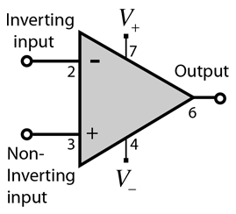

**Introduction**

This lab served as an introduction to the practical operational amplifier (op-amp), correctly wiring and powering the active component, and measuring the voltage at the output to determine the op-amp gain characteristic. Practical readings were compared to theoretical quantities for accuracy. A DC power supply was used to power the op-amp, and a signal generator supplied an AC input. An oscilloscope and digital multimeter were used to measure input and output voltages, and these readings were compared. In total, three op-amp configurations were wired; the inverting amplifier, the strain gauge amplifier, and the weighted summer.

**Purpose**

The ability to amplify and manipulate signals is crucial, especially in the world of analog design. For example, imagine a sensor that measures and records tiny fluctuations in a real-world quantity, such as temperature or light. These fluctuations may be registered by the sensor in the range of microvolts. For those readings to be used in a meaningful way, they must be amplified. This simple example ignores the problem of noise, which is amplified along with the desired signal, but illustrates how important amplification is in a practical sense. This amplification is achieved using op-amps.

A screenshot of a cell phone

Description generated with very high confidenceA close up of a logo

Description generated with very high confidence

**3 Discussion and Results:**

For part 1 my group mates and I had to properly setup an operational amplifier on a inverting configuration. A schematic was provided to my group and I on figure 1 showing us the inverting set up. Next, we were given the µ741 op-amp for our lab and notified to properly connect the external power supply to the correct pin. This op-amp required two 9-volt supplies in opposing polarities shown in figure 2. The op-amp also required a input V1 of about 500Hz sinusoidal with a 3 volts peak to peak and 0 offset. Then I calculated for Vo by using node voltage method and Kirchhoff’s Current Law. This gave me Vo = -V1 and Vo = -3V from this I was able to derive the voltage gain which gave me gain = -1V. Please note that -3V is the peak to peak voltage that was converted to Vrms later. Now after setting up the inverting amplifier we had to take measurements for V1 and Vo with the oscilloscope and digital multimeter. My group and I also took measurements of R1 and Rf. Now we compared our oscilloscope measurements with are DMM in order to verify the same readings. Now after converting Vo to Vrms  my group mates and i ended up with Vrms = 1.06 which compared to our oscilloscope and DMM readings were all close. Therefore, proving that my groups calculations and readings are accurate. Now for are gain we derived are circuit gain and theoretical gain and noticed that they were both close thus proving their accuracy as well. The phase relationship between input and output is about 180 degrees between each other. This relationship is true because we configured an inverting op-amp which flips the polarity and our reading between input and output were always the inverse of each other.

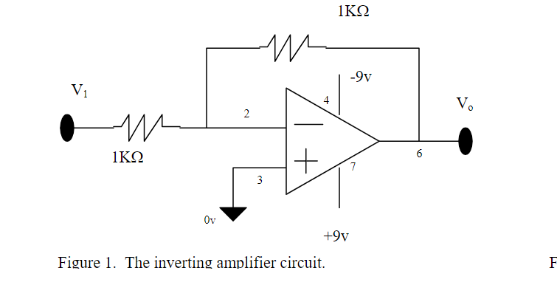

|  |  |  |
| --- | --- | --- |
| Voltages (rms) | Oscilloscope Measurement | Digital Multimeter Measurement |
| V1 | 1.09 V | 1.01 V |
| Vo | 1.10 V | 1.02 V |

Rf = .991 K (Specified 1 K)

R1 = .997 K(Specified 1 K)

**Theoretical Circuit Gain:** gain (v) = voutvin= -RfRin= -1 kΩ1 kΩ = -1

**Calculated Circuit Gain:** gain (v) = voutvin= -RfRin= -0.991 KΩ0.997 KΩ=-0.994 Ω

Phase relationship:

183-degree phase relationship, makes sense since Vo= -Vin

**Part II: Saturation in the Inverting Amplifier:**

This part is a continuation of part 1 as we are using the inverting op-amp configuration. My group and I were tasked to increase the applied peak to peak voltage until a distortion is found. My group and I discovered that at 3.7 Vp-p there was a distortion on channel 2 occurring. The seemed to increase the width of the peak voltage at the very top of the sin wave. Next my group and I recorded the maximum and minimum voltages found on the oscilloscope. After recording the maximum and minimum my group mates and I set the Vp-p back to 3V and applied a DC offset voltage and increased it until a distortion was found. My group and I discovered that at a DC offset of 1.3V distortion was observed from the oscilloscope. This distortion here was occurring both at Vin and Vout as it appeared as just squiggly lines alternating quickly.

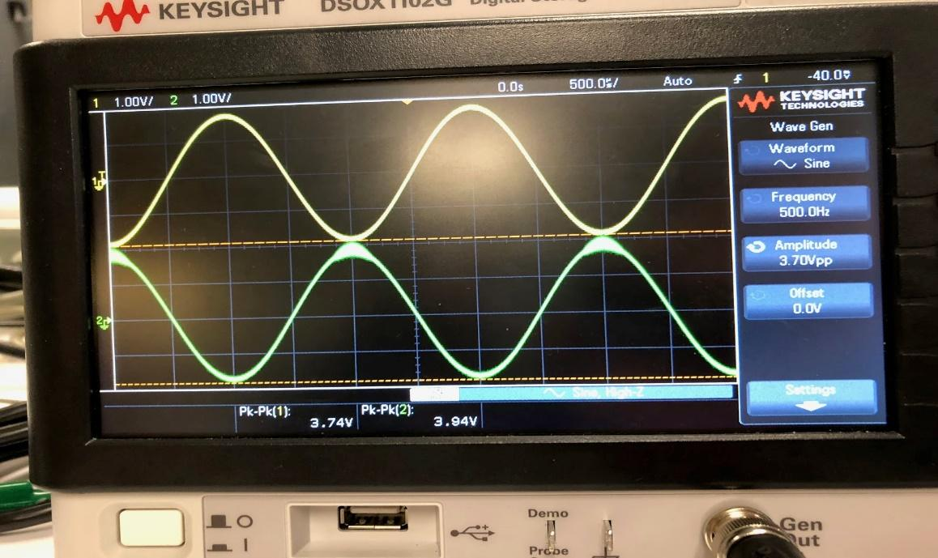

Increasing Peak to Peak Voltage

|  |  |  |
| --- | --- | --- |
| Voltages | Minimum  Measurement | Maximum  Measurement |
| V1 | -1.92 V | 1.82 V |
| Vo | -1.84 V | 2.1 V |

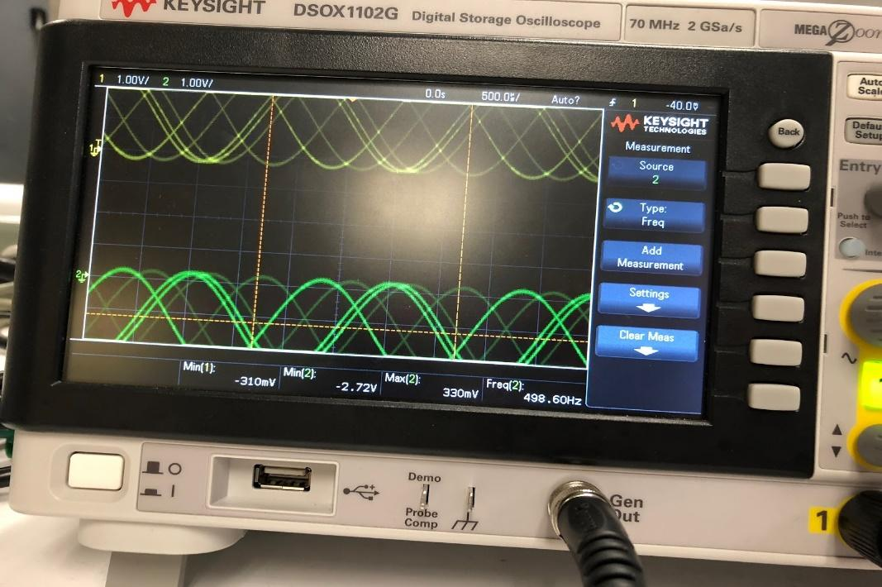

Reducing applied input voltages back to 3Vp-p while increasing the DC offset

|  |  |  |
| --- | --- | --- |
| Voltages | Minimum Voltage | Maximum Voltage |
| V1 | -310 mV | 2.72 |
| Vo | -2.72 | 310 mV |

**Part III Strain Gauge Amplifier Circuit:**

This part of the lab uses a single input inverting configuration shown on figure 4. This experiment uses the same signal in section I. However, this circuits configuration uses a lot more resistors and changes its resistance through each trail for delta R. This meant that my group and I had to record multiple readings for voltages for each uses of a different resistor. My group and I also compared our theoretical gain against our measured gain for each different case. My group and I also discovered that the phase relationship between the input and output signals was about 180 degrees apart. Therefore, proving the circuits configuration as it was inverting the input based on the 180 degree phase shift. The table below shows the multiple resistor my group and I used for this circuit as well with specified and measured values, lastly with a percent error for accuracy.

|  |  |  |  |
| --- | --- | --- | --- |
| Resistor | Specified Value | Measured Value | Percent Error (%) |
| Ro(bottom) | 2  KΩ | 1.99 KΩ | 0.5 % |
| Ro(top) | 2 KΩ | 1.99 KΩ | 0.5 % |
| R1(bottom) | 1 KΩ | 0.991 KΩ | 0.91 % |
| R1(top) | 1 KΩ | 0.995 KΩ | 0.5 % |
| ΔR1 | 0.2 KΩ | 0.204 KΩ | 1.96 % |
| ΔR2 | 1 KΩ | 0.991 KΩ | 0.91 % |
| ΔR3 | 4.2 KΩ | 4.29 KΩ | 2.09 % |

Table for ΔR1 = 0.2 KΩ

|  |  |  |
| --- | --- | --- |
| Voltages | Oscilloscope Measurement (V) | Digital Multimeter Measurement (V) |
| V2 | 1.06rms | 1.03 (rms) |
| Vo | .098rms | .069 (rms) |

Table for ΔR2 = 1 KΩ

|  |  |  |
| --- | --- | --- |
| Voltages | Oscilloscope Measurement | Digital Multimeter Measurement |
| V2 | 1.11 | 1.02 (rms) |
| Vo | 0.371 | 0.339 (rms) |

Table for ΔR3 = 4.2 KΩ

|  |  |  |
| --- | --- | --- |
| Voltages | Oscilloscope Measurement | Digital Multimeter Measurement |
| V2 | 3.14 pp -> rms value = 1.11 | 1.03 (rms) |
| Vo | 4.5 pp -> rms value = 1.59 | 1.47 (rms) |

**Part IV Weighted Summer:**

This part of the lab uses the two-input inverting configuration shown on figure 5. My group and I used a 2-volt peek-to-peek with a 500 Hz sinusoidal signal for input 1 and a 2 volts dc input for input 2. My group and I measured the output voltage with the DMM on both the DC and AC setting. Also measured the voltage with an oscilloscope with the added measurements of RMS and average with both AC and DC coupling. The table below shows the resistor values used for this part.

|  |  |  |  |
| --- | --- | --- | --- |
| Resistor | Specified Value | Measured Value (Ω) | Percent Error (%) |
| R(bottom) | 1 KΩ | 0.991 KΩ | 0.91 % |
| R1(top) | 1 KΩ | 0.994 KΩ | 0.91 % |
| R 2 | 2 KΩ | 2 KΩ | 0 % |

DMM Measurements:

|  |  |  |
| --- | --- | --- |
| Voltage | Digital Multimeter Measurement (DC Setting) | Digital Multimeter Measurement (AC Setting) |
| Vo | -1.996V | 0.344V |

Oscilloscope Measurements:

|  |  |  |
| --- | --- | --- |
| Voltage | Oscilloscope (AC Coupling) | Oscilloscope (DC Coupling) |
| Average Vo | -2.01 V | -2.04 V |
| RMS Vo | 349.17 mV | 2.07 V |

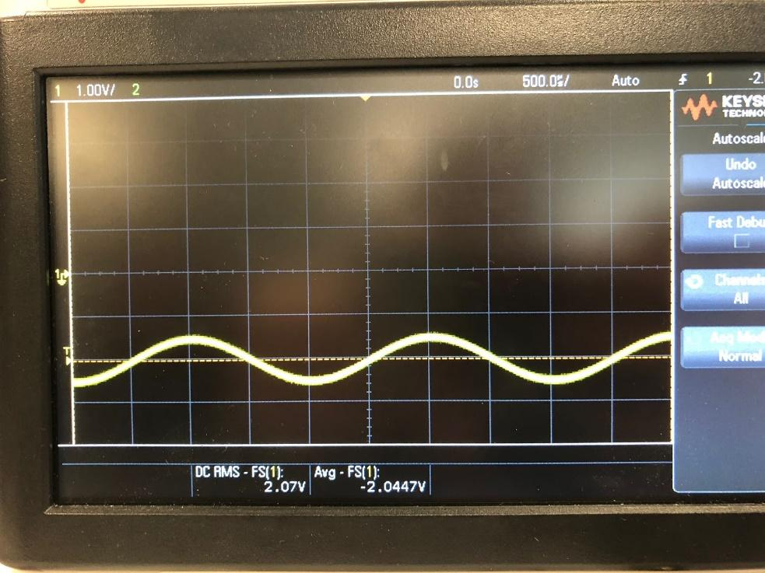

Output wave for part IV

**Conclusion:**

My group and I have shown how to calculate, measure, and analyze three different operational amplifiers. By using node analysis and KCL, I was able to calculate for each op amp so that I would know what to expect from my measurements. Possible sources of error include setting up the circuit incorrectly, faulty equipment, and incorrect measurements. I know for my group and I we were faced with multiple circuit set up because we were not consistent with our measurements and RMS conversions. Thankfully we were able to solve this issue and successfully complete this lab with the catch-up week. My group and I have learned a greater understanding on operational amplifiers and how crucial setting it up is.

**Appendix:**

Please look at the pre-lab calculations as they are what I use for calculations of this lab.